- To access the interface
The booking platforme is accessible on our website’s Home page www.camping-cap.com
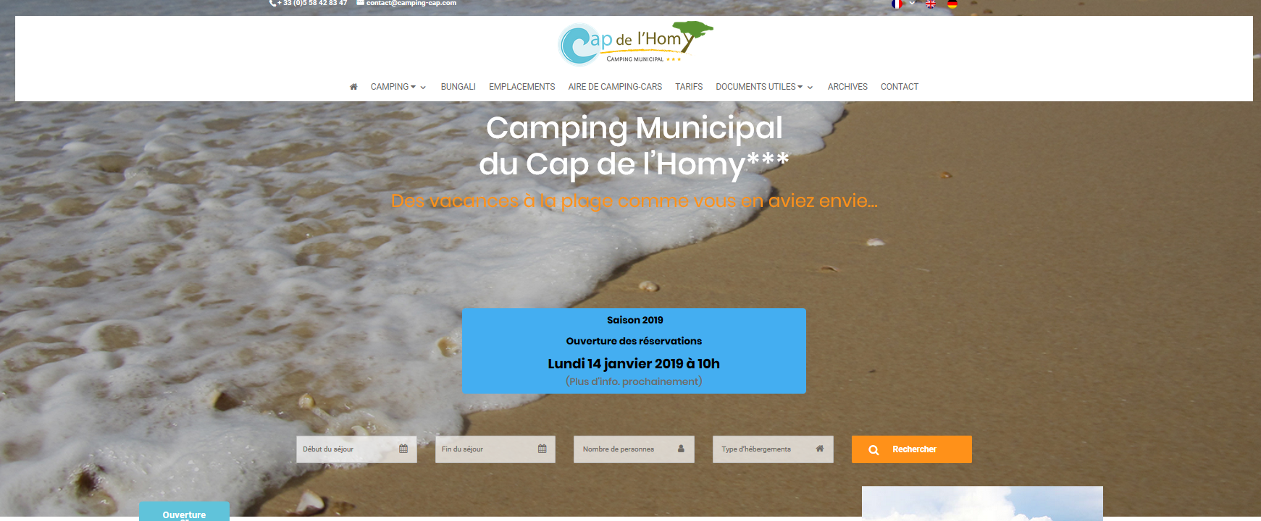

Complete here : arrival and departure dates, number of persons, type of accommodation (campsite/bungalow/lodge) +
- 1st page of this platforme Thélis Résa.
Reminder :dates of the stay, and accommodation
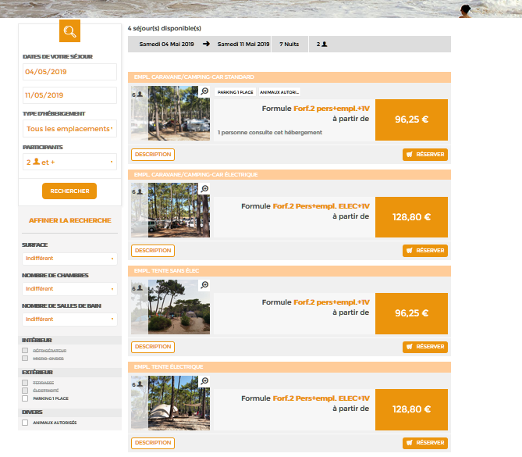

Pitches categories

Description of the differents categories for booking.
Beware, if the wisches category doesn’t appears means that any place is free for this category.

- Choose of category
Category description

1

1
Price
=
Package x Nbre of nightsit x Nbre de nuits demandés

Choose your accommodation

(Differents accommodations: Empl.Tente avec électricité, Empl. Tente sans électricité, Empl. Caravan/Motor home with electricity, Empl. Caravan/Motor Home NO electricity.)

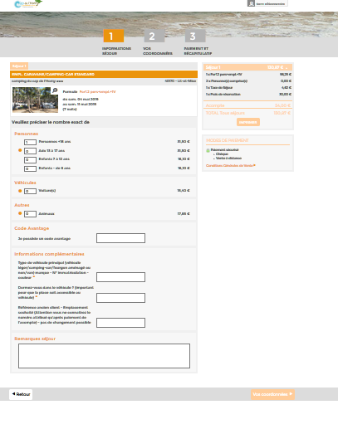
- Your cart = your stay
Estimate : amount of the stay = in real-time front of your information (nbre of night, peoples …)
This estimate can been print.

Composition of the stay :
Fill correctly :
- Nb of persons
- Nb of car (s) (main car included)
- Animal

Thanks to fill correctly this form. A place will be done front of this form (or not). Beware of the vehicules, some places are not suitable with motor home. (cf Notices)
Click on « Vos coordonnées » to continue

- Your personal datas :
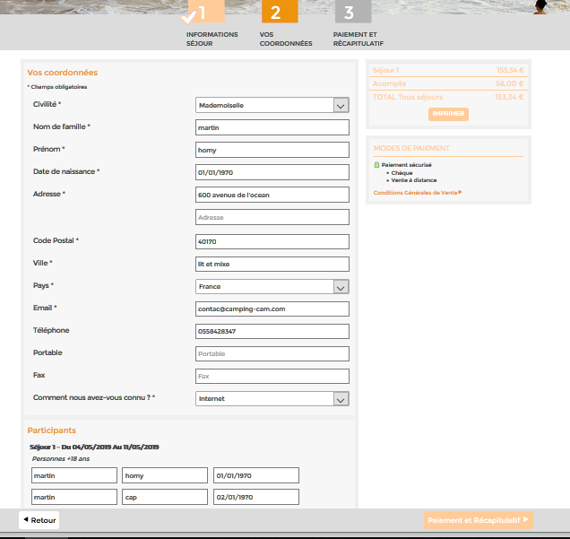
Reminder of total price

Complete your personal datas * Champs obligatoires

Click to continue

- Terms and conditions - validation
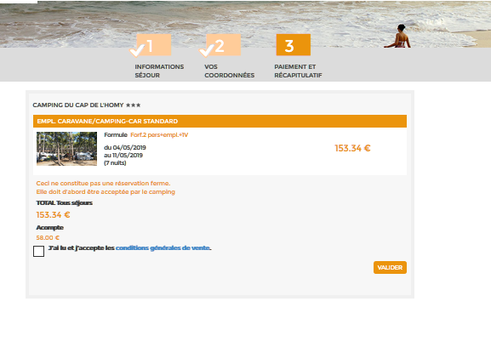

Tick to accept the terms and conditions + click on Valider to send the reservation
Amount of deposit mentionned on the estimate . The deposit payment confirm the booking. This price represents 25 % of total price of the stay (HT) + 30 € for booking fee.
- Confirmation of Pré-réservation.
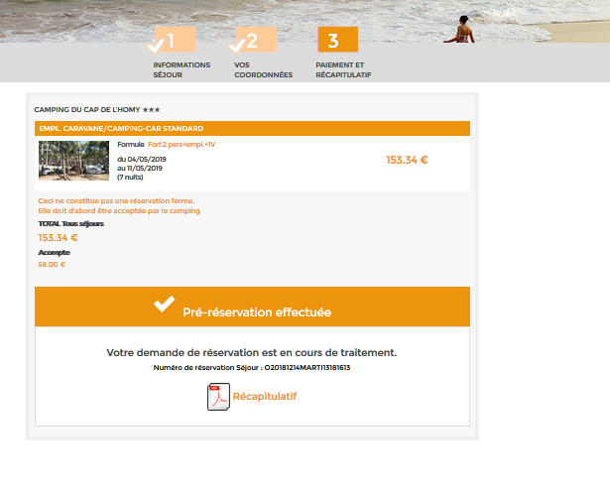

Beware this is not a definitive RÉSERVATION.
The campsite has to confirm

Your request of booking is finish and send to the campsite. You will get a delivery receipt. You can print a recap of the order in PDF.

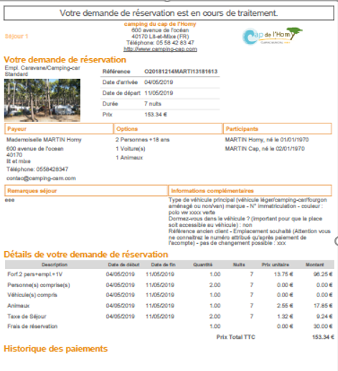

After processing time for your file (maximum 3 weeks) we will send you a quote stipulating your dates and the pitch attributed. The deposit payment methods will be explained (online payment via a weblink.)
Please consult the notice for more information.

La réception

